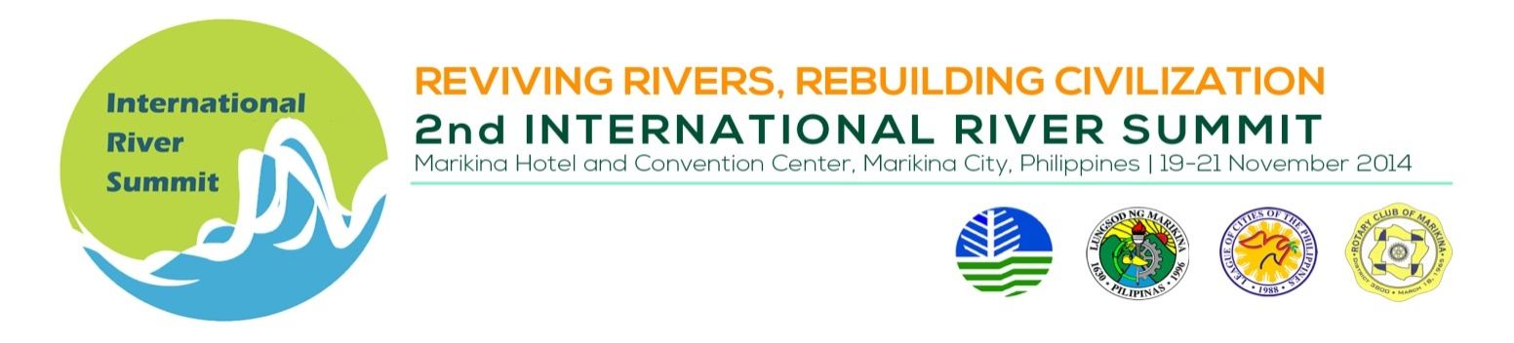
PLENARY SESSION DAY 3

Venue : Convention Center Plenary Hall

Date/Time : November 21, 2014, 9:00 – 12:00 NN

TIME | TOPIC
9:00 – 9:05 AM | Key Highlights of Summit Day 2
9:05- 9:35 | The Role of science and the academe in the Southeast Queensland Healthy Waterways Partnership | Dr. Eva Abal,  Director, UQ Water Initiative/ Chief Scientific Officer, Great Barrier Reef Foundation Office of the Deputy Vice Chancellor-Research  University of Queensland, Brisbane, Queensland, Australia
9:35– 10:05 | Public – Private Engagement for River Management Initiatives | Mr. T. Albert Nauta,  Regional Manager for South and East Asia/ Strategic Advisor, Integrated Water Management, DELTA RES, The Netherlands
10:00- 10:15 | BREAK
10:20 - 12:00 | Presentation on Philippine River Basins:  Marikina River Basin  Cagayan River Basin  Mindanao River Basin | Session Chair: Marcia Isip, Executive Director, River Basin Control Office  Panelists  Dr. Teodoro Villanueva,  Berkman International Inc.  Dr. Orlando Balderama,  Woodfields Consultants Inc.  Mr. Solomon Paz,  Woodfields Consultants, Inc.  (Panelists)
12:00 – 1:30 | Lunch at al fresco dining hall
1:30- 3:00 | 2nd IRS Closing Ceremonies
4:00 | City Tour (Optional)

